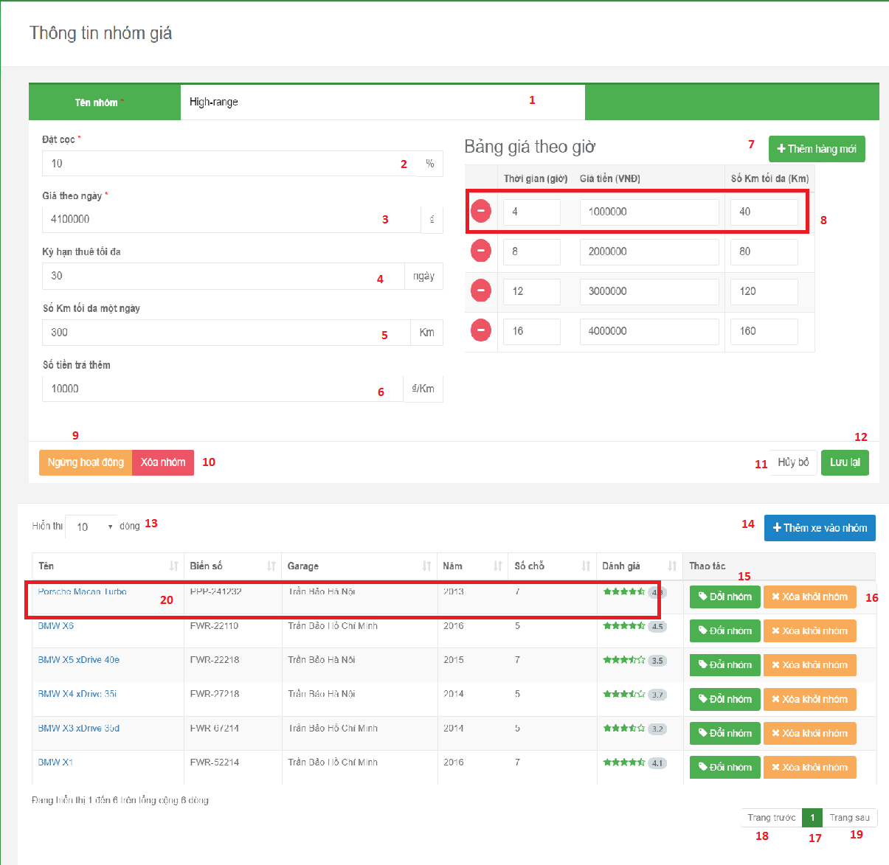

**Fields:**

|  |  |  |  |  |  |  |
| --- | --- | --- | --- | --- | --- | --- |
| No | Field Name | Description | Read Only | Mandatory | Control Type | Data Type |
| 1 | Vehicle group name | Allow user input name of vehicle group | No | Yes | Text box | String |
| 2 | Deposit | Input deposit for booking vehicle | No | Yes | Text box | Number |
| 3 | Price per day | Input money per day | No | Yes | Text Box | Number |
| 4 | Limit time | Input number day for rent vehicle | No | Yes | Text Box | Number |
| 5 | Limit Km | Input number km for rent vehicle | No | Yes | Text Box | Number |
| 6 | Money will pay by over the limit km. | Input money by over the limit km | No | Yes | Text Box | Number |
| 8 | Price per hour | Input money of price per hour | No | Yes | Text Box | Number |
| 13 | Filter number of record in data table | Choose the number will be displayed in data table | Yes | No | Drop down list | Number |
| 17 | Current Page Of Table | Current page of table | Yes | No | Text Box | String |

**Buttons/Hyperlinks:**

|  |  |  |  |  |
| --- | --- | --- | --- | --- |
| No | Function | Description | Validation | Outcome |
| 7 | Add new field to input price per hour of vehicle group | Show text box to input money per hour | N/A | Show text box field allow user input price per hour |
| 9 | Deactivate vehicle group | Vehicle group will be deactivated. | N/A | Vehicle group will be deactivated. |
| 10 | Delete vehicle group | Vehicle group will be deleted | N/A | Vehicle group will be deleted |
| 11 | Cancel edit vehicle group | Disable all field to edit vehicle group | N/A | User can not edit vehicle group |
| 12 | Update vehicle group | Send request to controller | N/A | Vehicle group will be updated |
| 14 | Add vehicle to this vehicle group | Add vehicle to vehicle group | N/A | Show pop up allow user choose then add vehicle to vehicle group |
| 15 | Switch vehicle to another vehicle group | Change vehicle group of vehicle | N/A | Show pop up allow user choose new vehicle group of vehicle |
| 16 | Delete vehicle from vehicle group | Delete vehicle from vehicle group | N/A | Delete vehicle from vehicle group |
| 20 | View vehicle in detail | View information of vehicle | N/A | Redirect to vehicle detail page |
| 18 | Show Previous Record Of Table | Show previous record of table | N/A | Show previous record of table |
| 19 | Show Next Record Of Table | Show next record of table | N/A | Show next record of table |